الجمهورية اللبنانية
وزارة التربية والتعليم العالي الامتحانات الرسمية لشهادة الامتياز الفني
المديرية العامة للتعليم المهني والتقني لدورة عام 2009 الثانية
===============
الاختصاص والرمز : المعلوماتية الادارية (24004)
المادة : التطوير التطبيقي بالانترنت المعدل: (8)
المستندات المسموح بها : لا شيء المدة : ساعة ونصف

N.B: All the "HTML" files are in the folder: webpages
All the "AUDIO" et "VIDEO" files are in the folder: webpages \sounds
All the "IMAGES" files are in the folder: webpages \photo
All others files are in the folder: webpages \misc
All colors should be used as WEB SAFE COLOR

I- Write the appropriate tags to obtain as result the following page " list.html" respecting the following conditions:  (5 pts)  - The Page title is "Spare Parts by car type ". Text color is red.  - Page Author is « author ».  - The first table background color is blue  - The second table borders have two colors, red and blue.  - The link "Download online Catalogue" will download the file "cat.pdf"  - Keep the page format. | 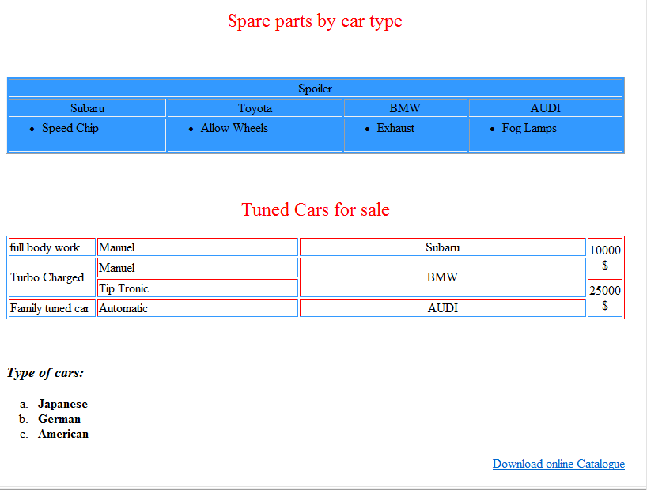
II- Write the appropriate tags to obtain as result the following page " main.html" respecting the following conditions:  (4 pts)  - Upon opening this page, and within 5 minutes, this page will be redirected toward "http://tune4all.com"  - Page background color is green.  - The name of the image is « wheel.png » and their dimensions are fixed as follow 80x80 pixels. It’s borderless.  - When you click on the picture, the video "wheels.avi" is embedded and continuously played.  - The message « Turn a simple car to a monster» is scrolling from the left to the right five times.  - Keep the page format | 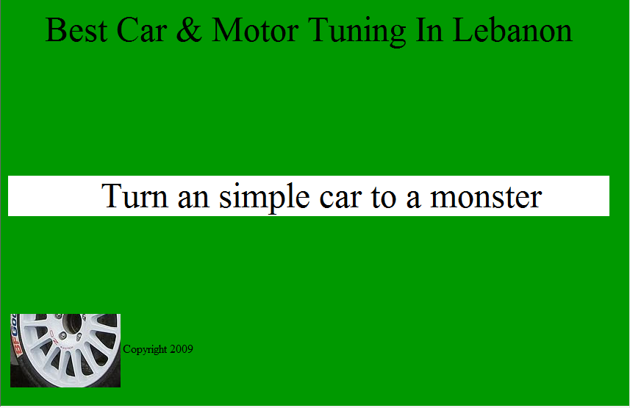
III- Enumerate four different simple tags that don’t need a closing tag.
(2 pts)

الاختصاص والرمز : المعلوماتية الادارية (24004)
المادة : التطوير التطبيقي بالانترنت المعدل: (8)
المستندات المسموح بها : لا شيء المدة : ساعة ونصف

 | IV- Write the appropriate tags to obtain as result the following page "Frame.html"  (4 pts)  - The page background is the image "Work.png"  - Car Brand: Entry field, 30 characters.  - Car Type: Choice between Sport car and Familly car.  - Car Model Year: Choice between four values, 2006. 2007. 2008 and 2009. 2008 value is selected by default  - Name: Entry Field, 20 Characters  - Email Address: Entry Field, 50 Characters.  - Type of tunes: Two values: Motor Work or Body Work.  - A button Submit to send all the information to the following email address: "tune@tune.com"  - A button Reset to restore all the default values of the page and erase the entered values. | 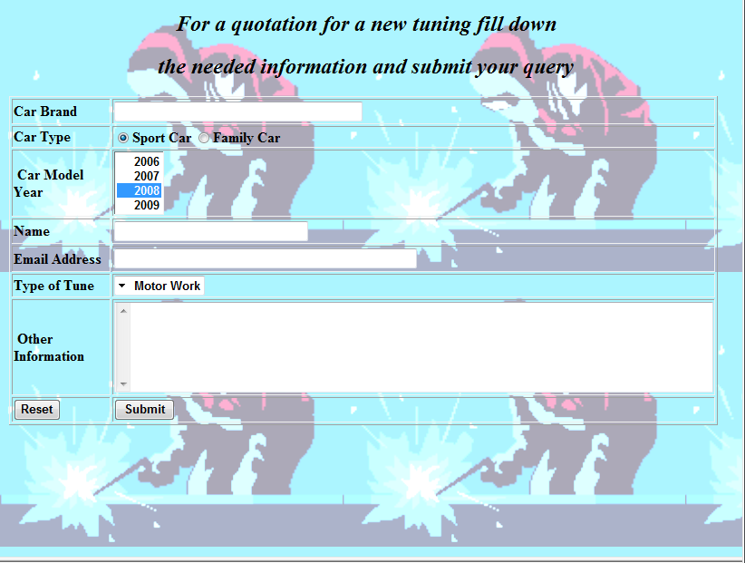
Frame A:
Width 70 %
Height:90%
V- Write the appropriate tags to obtain as result the following page "index.html"  (5 pts)  - This page is composed of three frames A, B and C.  - The first frame "A" displays by default the page "main.html" of the exercise II.  - The second frame "B" displays 3 links. The first link "Main page" displays the page "main.html" of the exercise II in the frame A. The second link "List" displays the page "list.html" of the exercise I in the frame A. The third link "Quotation" displays the page "frame.html" of the exercise IV in the frame A.  - The third frame "C" displays the picture "car.png". When you click on the image, an email will be sent to the address "info@tune.com." | 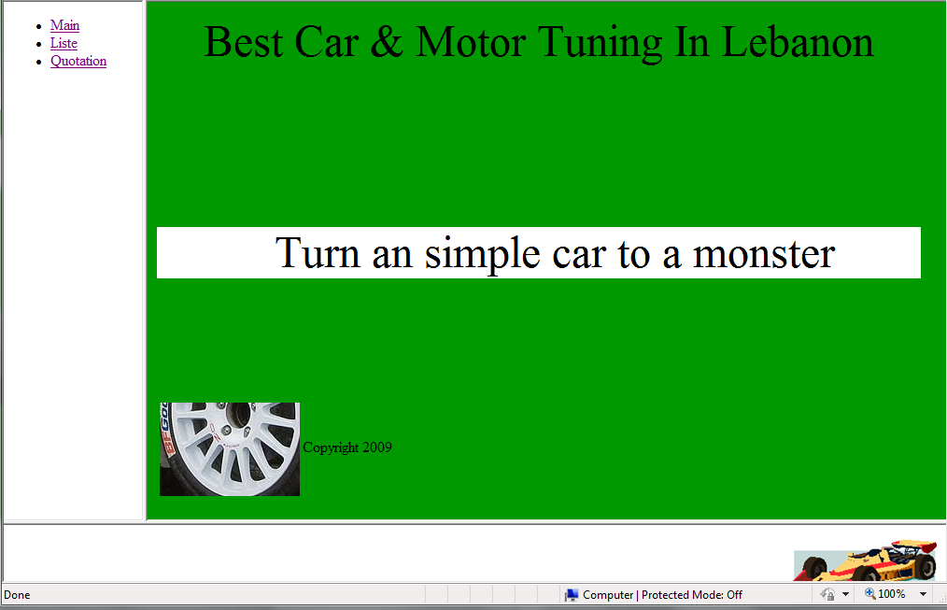  Frame B:  Width 30 %  Height:90%  Frame C:  Width 100 %  Height:10%

